Mouka W.E.T

1 Mouka Street, Alihame, Agbor, Delta State, Nigeria

233558468957, 233570464341, riko1010@protonmail.ch

March 16, 2023

**Facts and Evidences v3.1**

**FACTS AND EVIDENCES ON APRIL 19, 2022**

**and other dates**

**Facts**

I am Mouka Emmanuel, I work with Neural networks and artificial intelligence Limited (NNAI) as

a researcher and operations manager at Alihame, Agbor, Delta State, Nigeria. I study at

Lancaster University Ghana. My company specializes in security, counter surveillance. I plan to

join the Nigeria Police Force in 2021/2022. I have experience as a Private investigator.

1. I experienced attempts to rob and kill me and residents at my premises from 2021-2022. The

armed robberies started with theft of power generators, next, electrical materials and other

items were stolen. Progressed to poisoning of food and drinks in the premises which led to near

death experiences. Unknown persons tried to electrocute residents to death by placing a power

source on a metal door. Armed criminals regularly attack the premises fence during nighttime to

destroy the fence and property, the fences were re-enforced with metal rods to prevent collapse.

A CCTV system was acquired to identify the criminals. The attackers regularly damaged the

CCTV system. A CCTV Log book (Photo E1) was acquired to document the events.

On 12 February, 2022, Agbor Police was invited to the premises. A Police Officer named Duke

Amerika asked if there were suspects in the absence of video evidence. As at that date, I did not

have suspects. I sent 70,000 Naira(Photo E2) to the Police Officer in appreciation of his visit.

The attacks progressed to direct confrontations at my premises by armed persons without

cause. They attempted to kill me with witnesses present. I was saved by the intervention of two

persons during one of these attacks.

On multiple occasions I have met persons hurt at the premises, the local pharmacy treated such

persons. They claimed they got injured while performing their tasks. On an occasion, I

discovered one of the injured persons entered a locked section and left a blood trail.

I was detained without cause after experiencing several armed attacks while seeking police

assistance on April 19, 2022. The Police officers at Agbor police command on the instigation of the DPO assaulted, tortured and dehumanized me. They asked I write an accidental discharge occured, I refused. They present an unsigned statement from my detainment at Agbor. I did not give a statement at Agbor, I refused given they were dictating and I did not have my lawyer present. I was transferred to Asaba, Delta State Police Command, I was tortured on arrival, asked to write a statement which I refused without my lawyers present. An unknown lawyer whom I've reported to NHRC was brought by family members, he and the police listened to my account of events and decided they would write what they termed a "bailable" statement. They wrote a false account of an accidental discharge. I do not recollect signing that document as they continually exposed me to torture, dehumanization and assault without cause but they present a signed document from Asaba which they wrote themselves claiming an accidental discharge occured. I did not verbally dictate that, I dictacted that I was attacked on April 19, 2022 and other dates and there are witnesses both on April 19, 2022, and other dates including a report to Agbor Police Command. My lawyers contested this falsification of a statement at Asaba.

I requested for bail, they charged me 1 million naira which I paid but did not grant me bail. I also received a request for financial assistance from Officer Onyeama while I continually sought for the police to acknowledge the facts do not indicate a crime compared to the false statement they curated stating an accidental discharge occured. I gave Officer Onyeama 1 million naira on his request totalling 2 million naira paid. I reported to NHRC and notified Officers Onyeama and Blessing Edosa that they should review the "facts and evidences" compiled and act on my release to prevent prosecution for their falsification and negligence, they agreed and notified me they can act on closure of the case with the information provided but would need money to discharge the matter. I sought advise from the NHRC, Okechukwu .N, assigned by the Delta State Coordinator, Ngwu .A, advised I should not make further payments to the Police. I notified the Police that I would not make further payments and it is imperative that they act on closure and discharge of an innocent citizen whom they imprisoned unjustly with a statement they falsified. They refused without further payments. I notified NHRC of the response from the Police and requested they proceed with any action to establish my fundamental rights and discharge the unjust accusation against me.

While in police custody, the officers ignored my complaints that the threats are still existent. Another armed attack occured while detained (Photo E8). My family and staff was put in danger and considerable portions of my property was destroyed. The police officers did not act on the notification that an attack had occured at same property where I'm being falsely accused of murder when the facts are that on April 19, 2022, and other dates, I, my family and staff have been continually targeted for assassination and robbery.

**Major events and dates:**

On 27 September 2021, suspicious events occured(armed robbery), observing the CCTV system

showed scenes being replayed. This is evidence of tampering. (Photo E1)

On 28 September 2021, suspicious events occured(ACT OF GOD). (Photo E1)

On 31 September 2021, suspicious events occured(armed robbery), the CCTV system

failed(DVR failure). It was impossible to get video evidence of the events that occured. (Photo

E1)

On 31 September 2021, suspicious events occured(armed robbery), the CCTV system had no

video evidence available. An auto format was triggered which damaged video evidence. (Photo

E1)

On December 2021 - January 2022, suspicious events occured(armed robbery), blackout on

CCTV system. (Photo E9)

On 25 January 2022, suspicious events occured(armed robbery, food poisoning suspected), the

door was left unlocked after the incident. (Photo E1)

On 12 February 2022, Agbor Police was invited to the premises, Officer Duke Amerika received

complaints of theft, armed robberies, others attacks and advised it could be spiritual if the

attackers were able to carry out attacks and tamper video evidence. 70,000 Naira was given to

Office Duke Amerika in appreciation of his visit and expectation of action to identity and arrest

the criminals. (Photo E2)

On 16 February 2022, suspicious events occured(armed robbery, forced entries which damaged

doors, poisoning suspected). Suspects were identified but gave excuses that they acted in error

and gained access because doors were left open, this claim was untrue as the doors are always

locked for security reasons. (Photo E1, Photo E3)

On 18 February 2022, suspicious events occured(armed robbery, forced entries which damaged

doors, poisoning suspected). Suspects were identified and gave excuses that they acted in error

and that the doors were left open, this claim was untrue as the doors are locked for security

reasons. Efforts were increased to prevent such entries such as notifying persons not to enter

and notifying staff to keep the gates and doors locked at all times. (Photo E1, Photo E4)

On 21 February 2022, suspicious events occured(thefts, poisoning suspected), the CCTV

system experienced blackouts suspected to be from the attackers. This event exposed the solar

power system as not charging from sunlight. Considerable financial damaged was suffered

during this event. (Photo E1, Photo E5, Photo E6)

On 4 March 2022, suspicious events occured(thefts, poisoning suspected), the CCTV system

experienced blackouts suspected to be from the attackers. The premises experienced power

failure suspected to be intentional bridging of the power system. (Photo E1)

On April, 2022, suspicious events occured(assassination attempts), an assassination attempt

where I was saved by two persons, Okafor and Emmanuel. I took action after the failed

assassination attempt to report to my family, the Agbor Police and seek solutions. (Witnessed)

On 19 April 2022, suspicious events occured(thefts, assassination attempts, poisoning

suspected), multiple attackers were at the premises. I was saved by Okafor and Emmanuel

during the previous attack. I was detained while seeking Police assistance without cause. All

appointments were closed at 3pm, notice was given to all persons including staff on site.

Engr.Emmanuel who was on-site received a notice to end all activities at 3pm. The premises did

not receive or grant entry to anyone past 3pm. (Photo E11)

On 19 April 2022, Agbor Police Officer Duke Amerika visited the premises. Officer Duke received

the reports of robberies on February 12, 2022 when he was invited and is the first person

notified of incidents at the premises. (Photo E7)

On April - May 2022, suspicious events occured(thefts, assassination attempts suspected),

Considerable portions of my property was destroyed by armed attackers. They had previously

tried destroying the property before I expanded through acquisition of the neighbouring land. I

reported to the investigating police officers while in custody. They did not act on the report as at

the time of the incidence. (Photo E8)

I requested my family members report the incident while detained, they notified me that Agbor

Police stated the attack was malicious damage and did not incident the report as at the time my

family reported. The attackers have made efforts to kill me and residents, a failed assassination

attempt should not be classified as malicious damage and if it was, no arrests have been made

to get confessions on the reasons I am being targeted. (Witnessed)

On 21 November 2022, I requested for assistance from Police Officer Nkiruka who took action

to investigate my complaints and incident the attacks at Agbor Police station. (Witnessed,

incidented)

**Methods of entry**

The armed attackers confronted me directly on multiple occasions, the known methods of

entry are through the fencing, breaking the doors of offices/rooms/kitchen with visible damage,

the front gate through an unknown means as it is always locked, the roof and other unknown

entry points. (Photo E10)

**Human rights contact**

On 15 June 2022, I contacted National human rights commission (NHRC) Asaba, Delta State, Nigeria. Ngwu Alphues assigned Okechukwu .N to assist me with the situation. I provided the account of events, provided the witnesses to the assassination attempts and was requested to provide a detailed account of challenges suffered.

**Facts**

The complainants who were unlawfully empowered to complain against Mouka Emmanuel by reason of unlawful detainment of Mouka Emmanuel while attempting to complain about the April 19, 2022, attack, at Agbor Police Command alleges that Mouka Emmanuel violated the Laws of the Federal Republic of Nigeria by commiting murder.

April 19, 2022 incident was reported to Agbor police command, officer duke amerika received an account of what was occuring. Agbor police command tried to enforce a complaint on me stating an accidental discharge occured, I refused. I preferred to give a factual account of robbery and assassination attempts targeted at me and my family. Previous incidents were reported to police officer duke Amerika of Agbor police command with an invitation on February 12, 2022, reports were also made to other persons to help with the armed attacks.

Place of incident being property of Mouka Emmanuel, place of incident owned by Mouka Emmanuel, place of incident being private property with notice of prohibition of unauthorized entry recently and always given to all staff, including New age solar shop Agbor and visitors. New ago solar shop staff, happy was not invited on April 19, 2022. The evidence (Photo E11) proves that new ago solar shop was not invited. Additional reasons for unauthorized entry being prohibited include recent assassination attempts, robberies and incidents in the premises carried out by unknown persons and suspects that can listed, described by Mouka Emmanuel and witnesses of multiple events to aid investigation and arrest by Police or other law enforcement agencies.

**Issues:**

* Can murder be committed against an uninvited person in private property ?
* Can the complainants who were not witnesses to the event on April 19, 2022 assume and accuse the owner of the property who is also the victim and witness of burglary, forcible entry, attempt to murder and an attack against a private property of murder ?
* Can the victim of assassination and robberies which were reported to the police at the same property be accused of murder ?
* Does the accusers complaint state a motive ?
* Was April 19, 2022, incident reported to police, were previous incidents reported to police, who were they reported to ?
* Where did the April 19, 2022 incident and incidents on other dates occur ?
* Who owns the property ?
* Is the property a private property ?
* What is the definition of burglary, forcible entry and attempt to murder on April, 19, 2022, and other dates before it ?
* What is the definition of robbery ?
* Was the party claimed to be dead invited ?
* Has the party claimed to be dead and associated persons been involved in criminal activities before April 19, 2022 ?
* What are the consequences of Police misconduct on this false charge of murder ?

**Rule of law:**

Robbery, burglary, forcible entry, attempt to murder are felonies in the Nigeria criminal code. These crimes attract jail terms and capital punishment in some circumstances. Mouka Emmanuel suffered all these crimes on April 19, 2022, and other dates. Mouka Emmanuel cannot commit the crime of murder on April 19, 2022, while suffering these crimes from unknown intruders.

The complaint of murder against Mouka Emmanuel requires witnesses and not just claims presented as exhibits such as complaints by persons that did not witness the events of April 19, 2022. The process of establishing an accusation against another must reflect facts, the victim, Mouka Emmanuel who was attacked in his private premises is being accused of murder by persons that are not witnesses. The complainants are not witnesses and have not bothered to ask what occured. They took advantage of me being detained for being rude to complain against me while the police prevented me, the first complainant from reporting the crime on April 19, 2022.

Mouka Emmanuel being a victim of assassination and robbery which were reported to the police cannot be accused of the murder of an uninvited person, while in police custody, an attack against my property occured. This proves that the threat to the life of Mouka Emmanuel has been persistent before, during and after April 19, 2022. The Police at Agbor and Asaba are wrong to detain or charge Mouka Emmanuel before a court for a crime.

The accusers do not indicate knowing a motive for causing death of the party claimed to be dead. Murder is a fairly serious accusation, what could be the motive of the owner of a private property that has experienced multiple assassination attempts in commiting an act of murder ? The person claimed to be dead was not invited.

Report was given to Officer Duke Amerika on April 19, 2022, while detained for being rude. Report and invitation was made to Officer Duke Amerika on February 12, 2022 for robbery, assassination attempts. Report was also made to my brother Samuel who has a good relationship with local vigilantes that support the police in enforcing law in Agbor. The incident occured at the private premises of Mouka Emmanuel, No. 1, Mouka Street, Opposite Obison Hotel Road, Alihame, Agbor, Delta State, Nigeria. The premises is owned by Mouka Emmanuel. It serves as the Agbor office of NNAI Ltd, and a residence. It is a private property not open to visitors without invitation, the property is gated, secured with CCTV, electric security fence and barbed wires. A security post overlooking the property to prevent attacks and unauthorized entry from the roof was built at the peak of these assassination attempts.

The incident on April 19, 2022, February 12, 2022, and other dates constitute robbery, attempt to kill, and other crimes. The means of entry constitutes Burglary and other crimes as defined in the Nigerian criminal code. The attackers on April 19, 2022, February 12, 2022 and other dates as listed in the dated events in this document committed an act of Burglary by means of unauthorized entry. Section 410 of the Nigerian Criminal Code Act defines Burglary: Housebreaking: and like offences as A person who breaks any part, whether external or internal, of a building, or opens by unlocking, pulling, pushing, lifting, or any other means whatever, any door, window, shutter, cellar flap, or other thing, intended to close or cover an opening in a building, or an opening giving passage from one part of a building to another, is said to break the building. A person is said to enter a building as soon as any part of his body or any part of any instrument used by him is within the building. A person who obtains entrance into a building by means of any threat or artifice used for that purpose, or by collusion with any person in the building, or who enters any chimney or other aperture of the building permanently left open for any necessary purpose, but not intended to be ordinarily used as a means of entrance, is deemed to have broken and entered the building. The event on April 19, 2022 and other dates as listed in the events in this document constitute burglary. Section 411 of the Criminal Code Act in Nigeria defines Housebreaking: burglary as Any person who‐ (1) breaks and enters the dwelling‐house of another with intent to commit a felony therein; or (2) having entered the dwelling‐house of another with intent to commit a felony therein, or having committed a felony in the dwelling‐house of another, breaks out of the dwelling‐house, is guilty of a felony and is liable to imprisonment for fourteen years. If the offence is committed in the night, the offender is liable to imprisonment for life. Suspects of the burglary on April 19, 2022, and other dates before and after it, including while in Police custody are liable for the crime of burglary and other crimes, and it's associated punishment on conviction.

Unlawful entry indicated as forcible entry is a crime, the evidence of forcible entry is present in exhibit (Photo E8, E10). Section 81 of the Criminal Code Act in Nigeria defines Forcible entry as, Any person who, in a manner likely to cause a breach of the peace or reasonable apprehension of a breach of the peace, enters on land which is in actual and peaceable possession of another, is guilty of a misdemeanour and is liable to imprisonment for one year. It is immaterial whether he is entitled to enter on the land or not. The April 19, 2022, event and other dates before it, and the attack and destruction of my property while in Police custody at Asaba are forcible entry and attempt to murder amongst other crimes as defines in the Criminal Code Act in Nigeria perpetrated by the attackers. Witnesses to these events includes Okafor, Engineer Emmanuel, Happy and other persons, some of whom have saved my life from armed attackers during such events.

Robbery has been a criminal act suffered alongside forcible entry and attempt to kill on April 19, 2022, and other dates before. Section 402. of the Criminal Code Act in Nigeria. Punishment of robbery. (1) Any person who commits the offence of robbery shall upon conviction be sentenced to imprisonment for not less than 21 years. (2) If‐ (a) any offender mentioned in subsection (1) of this section is armed with any firearms or any offensive weapon or any obnoxious or chemical materials or is in company with any person so armed; or (b) at or immediately before or immediately after the time of robbery the said offender wounds any person, the offender shall upon conviction be sentenced to death. The invitation of Agbor Police Command, Officer Duke Amerika on February 12, 2022, was in response to robbery and other crimes. The thefts has spanned Electrical items, company property and resources, CCTV footage of criminal events, documents, valuables. The crime of robbery attracts serious punishment, the attackers have on some occasions been armed when commiting the crimes with impunity as witnessed during recent robbery and assassination attempts in May - April 2022.

Attempt to murder as defined in Section 320 of the Criminal Code Act in Nigeria. Attempt to murder (1) attempts unlawfully to kill another; or (2) with intent unlawfully to kill another does any act, or omits to do any act which it is his duty to do, such act or omission being of such a nature as to be likely to endanger human life, is guilty of a felony and is liable to imprisonment for life. The attacks before April 19, 2022, one of which was witnessed by Engineer Emmanuel and Okafor indicates an attempt to murder. The April 19, 2022, is a continuation of the attempt to murder with same attack methodology involving trespassing on my property without invitation with attempt to murder.

New age solar shop Agbor was notified on April 19, 2022 that we were closed for business on 3pm. A visit by new age solar shop staff happy, as received in a notice by text message notified of being at the premises of Mouka Emmanuel at Alihame by 12:10 PM. Mouka Emmanuel left Agbor to Asaba to receive products from Konga before 12:10PM, Mouka Emmanuel complains about losing consciousness in the charter vehicle on the return trip from Asaba and being taken to an unknown location which was claimed to be evasion of task force by the charter driver. The response to New age solar staff Happy, was closure of business by 3PM at the company premises Alihame, Agbor, Delta State. This text message was sent to Happy at 2:05 PM by Mouka Emmanuel while at Asaba. Mouka Emmanuel closed business on return from Asaba at 3PM. Another notice asking the whereabouts of Happy was sent at 3:05 PM after receiving the last guest for the day, Engineer Emmanuel. New age solar shop staff, Happy, was not invited on April 19, 2022.

New age solar shop has a habit of its staff appearing wonded in the property from unknown causes. This attempt to accuse me of a crime may have started before April 19, 2022, I complained about new age solar shop staff accessing my private property through forcible entry and burglary as evident in exhibit(Photo E4, E10) on February 18, 2022 and other dates. I invited Office Duke Amerika on February 12, 2022, due to increased rate of robbery, burglary, forced entry, and other crimes. I found a new age solar shop staff injured with blood all over his body, I do not know his name. He attempted to feign ignorance but I insisted he tell me what occured, he claimed he was injured while working. I had no reason to doubt but discovered he entered a private and locked section of the property leaving a blood trail and commiting an act of burglary, forcible entry, and attempt to murder by reason of food poisoning and other means. If the blood was fake or the event staged then new age solar shop may have tried to ochestrate a situation where they would accuse me unjustly before the April 19, 2022 attack. Ruth and Maxtino are witnesses of the aftermath of poisoning attempts. When Happy was found without invitation in the premises as on other occasions where persons have carried out criminal activities, including new age solar shop staff, he asked for forgiveness. This is not the first events involving new age solar shop staff being found wonded and having no credible explanation in the premises with crimes evident as indicated in events and exhibits. The gate has continually suffered attacks that has seen continually modification to provide better security. The fence and other infrastructure show evidence of being utilized in forcible entry and housebreaking.

Agbor Police Command and Delta State Police Command, Asaba, violated the basic human rights of Mouka Emmanuel through torture. The Anti-Torture Act 2017, Section 2, "Acts of torture" defines torture. "torture is deemed committed when an act by which pain and suffering, whether physical or mental, is intentionally inflicted on a person to – (a) obtain information or confession from him or a third person; (b) punish him for an act he or a third person has committed or suspected of having committed; or (c) intimidate or coerce him or third person for any reason based on discrimination of any kind". The Act states that (a) physical torture, which refers to such cruel, inhuman or degrading treatment which causes pain, exhaustion, disability or dysfunction of one or more parts of the body, such as - (i) Systematic beatings, head-banging, punching, kicking, striking with rifle butts and jumping on the stomach, constitutes torture. Agbor Police Command committed the crime of torture on April 19, 2022. Delta State Police Command, Asaba, committed torture on April 20, 2022, Officers Onyeama and Blessing under he directives of the O/C Homicide, Yakubu, are primarily responsible alongside their superior officers who authorized use of torture in receiving a statement. I refused without my lawyer present. The crime of torture according to the Act was perpetrated by Agbor Police Command, Agbor, Delta State, and Delta State Police Command, Asaba, Delta State. The Act states that (1) A person who contravenes section 2 of this Act commits an offence and is liable on conviction to imprisonment for a term not exceeding 25 years. I highlighted these facts to Officers Onyeama and Blessing after reporting their wrongdoing to NHRC, I asked they review the facts of the case they unlawfully refused to take in writing and discharge the matter they unlawfully charged before Agbor Magistrates Court, Alihame, Agbor, Delta State and subsequently Umunede High Court, Umunede, Delta State.. They reviewed the facts and evidences and told me they would discharge the matter but need money to act on the discharge. Okechukwu .N from NHRC advised that I should not make further payments to the officers. I notified the officers that they are required to act on my release without further upfront or advanced fee demands. As at March 16, 2023, they have not acted on my release. Officers Onyeama and Blessing Edosa of Delta State Police Command, Asaba, violated my rights by requesting 1million naira for bail, they have not granted bail as at March 16, 2023. They requested 1 million naira for assistance around 15 August 2022. The officers at Agbor Police Command, Agbor, and Delta State Police Command, Asaba, Delta State, committed the crime of I posing their preferred account of events and falsifying a statement when I refused to write their preferred account which ignored the attacks I had experienced including the April 19, 2022, incident and encouraged the trackers to carry out another attack while in police custody at Asaba. The method of compiling the case file is unlawful, I resisted being taken to my own premises as a scene of crime because the victim is me and my family, they used force that amounts to torture in getting in hand cuffs to my property at Alihame, Agbor, Delta State. They detoured and parked outside the morgue at General Hospital Agbor. They left me in the vehicle with handcuffs and went away, my cousin and the officers came running, claiming that there was a threat inside the morgue. How would an autopsy be presented when evidently there is something wrong with the inspection of the person they claim is dead ?. How factual is the claim of death ?. I also protest against the action of the Officers who notified me that they were taking action towards the burial of a potential suspect in the attacks I have experienced when I list suspects in my complaints, I asked the officer if they would have an explanation for approving the burial of the person they claim is dead when I've indicated that I was robbed and targeted for assassination. The officer did not stay his action on progressing with a burial as they also claim while I was kept at Agbor prison without providing a factual statement indicating the event of April 19, 2022, being a crime against me at my private property.I have continually asked why they would solicit funds from someone they're wrongly charging for murder. Why will the court would accept the case file presented that is full of discrepancies and lacks witnesses ?, Why will the ministry of justice refer to exhibits in its advise that are full of errors such as not correlating to the accusation of murder ?.

**Suspects**

The life of Mouka Emmanuel has been continually threatened before April 19, 2022, during and after, including while in police custody at Asaba Delta State for 35+ days. Naming and identifying suspects would lead to arrests of these persons who have shown impunity by continuing attacks at my property while detained. Persons who attacked the property of Mouka Emmanuel on April, 19, 2022, are suspects. Armed attackers who attacked prior to the April 19, 2022 incident are suspects. Persons identified to have gained forcible entry and committed burglary by reason of destroying property while gaining forcible entry are suspects. These crimes attract prison time. I am also concerned for my safety and my family's. I have also considered advise of persons supporting that in a community such as Agbor, the strong community and family ties means it is possible to identify and resolve the reasons for these armed attacks and robberies without focusing on arrest of suspects to reduce aggravation from these criminal entities. If I can avoid listing the suspects alongside my witnesses, I will. Myself and my witnesses can name, identify and give account of what these suspects mentioned have done including physical description and names where possible.

**Request**

* The Ministry of Justice is requested to withdraw the State's interest and falsified charge of murder in light of this document and evidence. It is shameful for the Ministry of Justice to prosecute a victim.
* The NPF is required to withdraw the false charge by Delta State Police Command, Officers Onyeama and Blessing Edosa with an apology for falsification of a statement, extortion and other crimes.
* The accusers who are not witnesses to the April 19, 2022, incident are hereby informed with this document, a withdrawal of their accusation is immediately requested. If there are areas of interest such as desiring to understand what occured, when I'm released, I will make efforts to carry out further investigations and make available the finding publicly.
* My lawyers are required to act with the documents, facts and evidences, violations, as the guiding instructions for all actions. These documents also serve as facts in relation to the April 19, 2022 incident and other dates.
* The media is authorized to publish contents of the documents "facts and evidences", "violations", a preference for the latest version is encouraged but all versions are factual, the continued improvements reflects facts that were omitted to protect identities of persons involved.

# Exhibits / Evidences

The exhibits / evidences listed in the document are presented below.

1. E1 - CCTV Log Book acquired to document attacks. The video evidence was regularly stolen or destroyed.
2. E2 - Report of burglary, forcible entry, attempt to kill and invitation to Agbor Police Command, Officer Duke Amerika on February 12, 2022.
3. E3 - This evidence was deleted by an unknown party, warning and publication notifying persons carry out such actions on my possession to cease and desist was carried out.
4. E4 - Complaints of burglary, forcible entry, attempt to kill, robbery, poisoning concerns.
5. E5 - Solar and CCTV System
6. E6 - Complaint against faulty CCTV and Solar enabling continued burglary, forcible entry, attempt to kill, poisoning, robbery.
7. E7 - April 19, 2022, Police visit by Officer Duke Amerika, Agbor Police Command.
8. E8 - burglary, forcible entry, attempt to kill, April 19, 2022, before, and while in Police custody.
9. E9 - burglary, forcible entry, attempt to kill, poisoning, robbery, made possible by unexplained faults in CCTV system.
10. E10 - Evidence of burglary, forcible entry, attempt to kill, robbery, poisoning. Gates, fences, other areas show same evidences.
11. E11 - Evidence indicating New age solar shop staff, Happy, was not invited on April 19, 2022.

**E1 - CCTV Log Book**

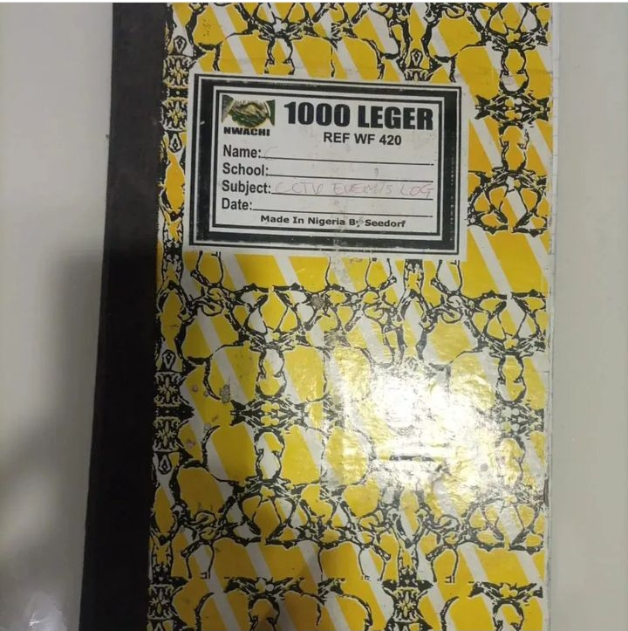

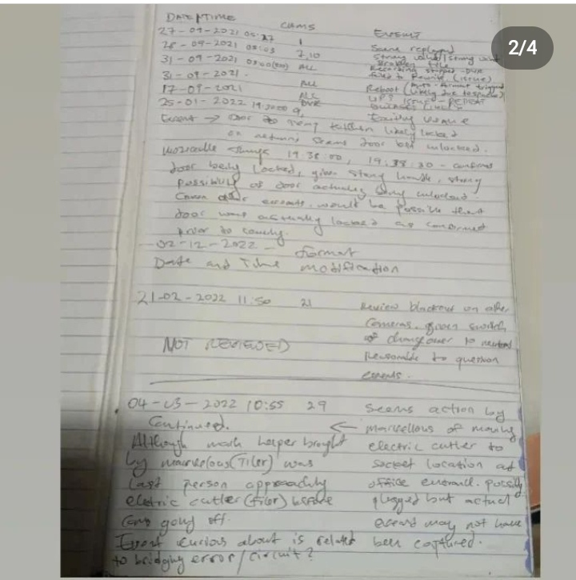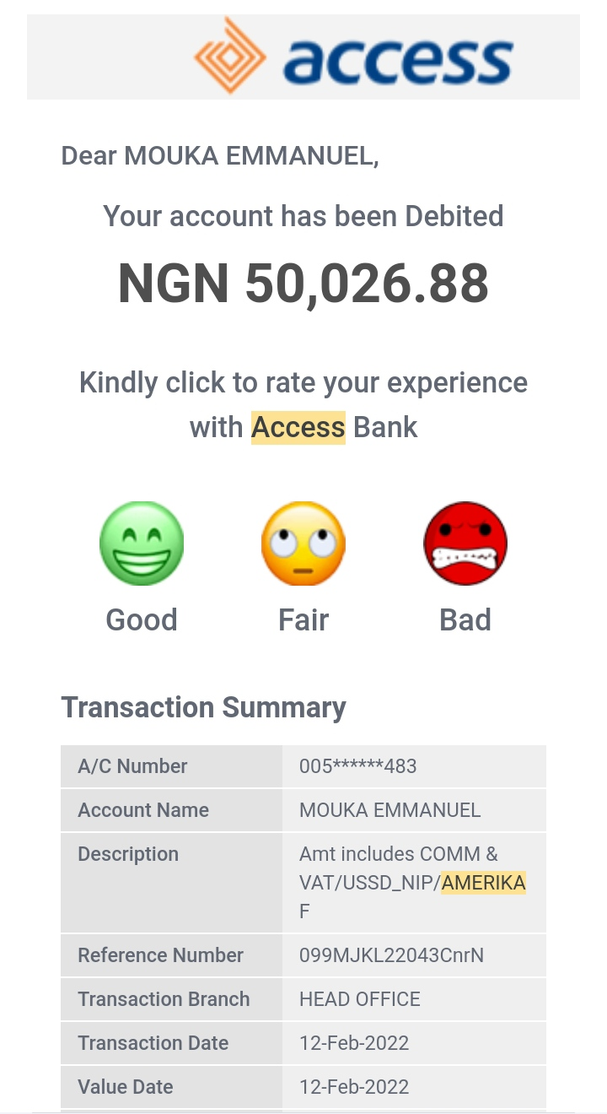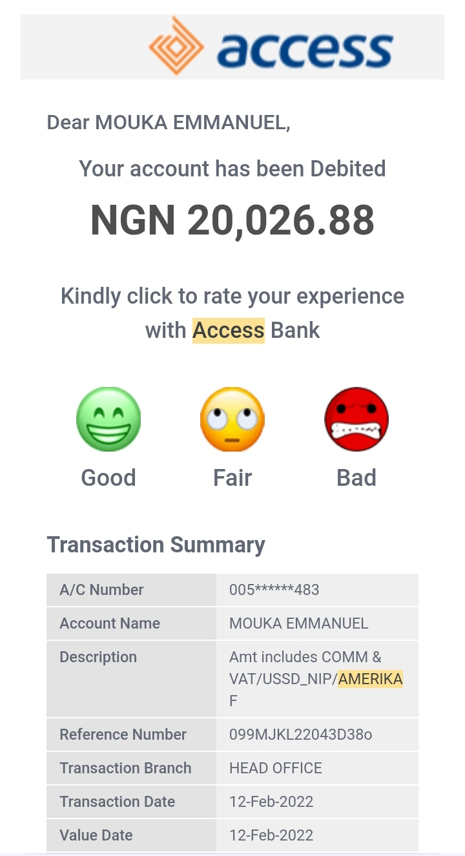**E2 - 70k to Police Officer Duke Amerika (Event on February 12,2022)**

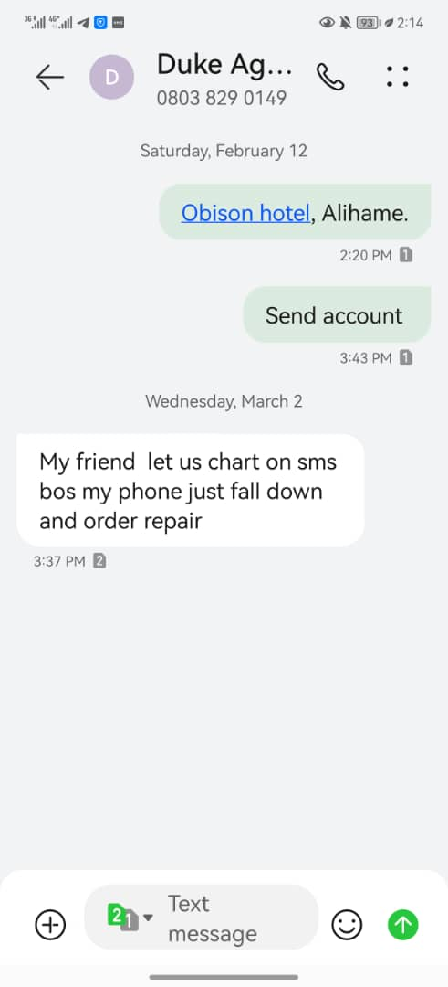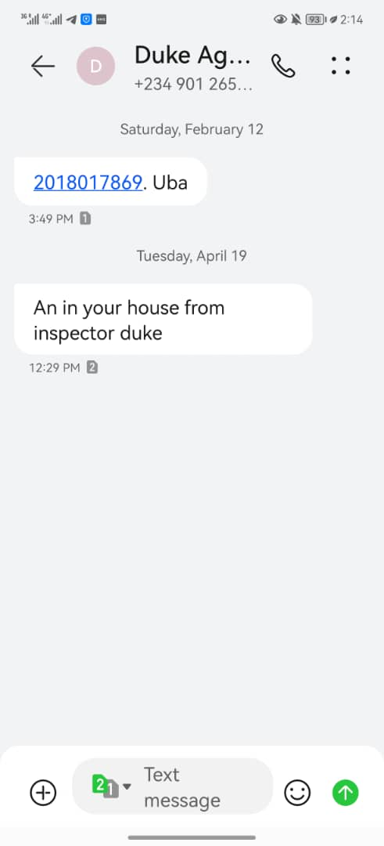**E3 - suspicious events, discovered persons at unauthorized areas, concerns and efforts to find persons.**

*Verbal confrontations in some cases if the persons are not carrying out criminal action.*

*In cases where a robbery was in progress, I do not confront the intruders but notify the police, identify what was stolen or report to persons with law enforcement capacity.*

**E4 - suspicious events, discovered persons at unauthorized areas, concerns and efforts to find persons.**

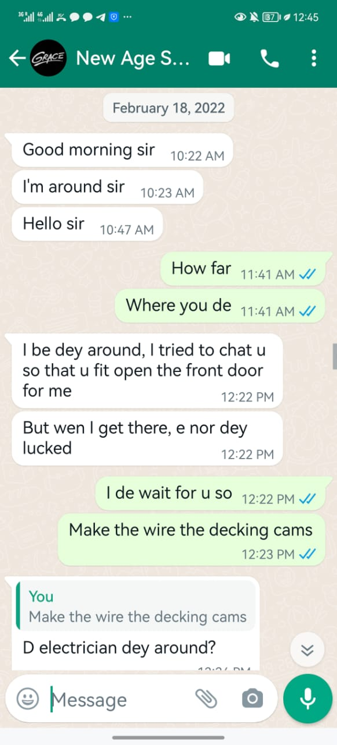**E5 - solar system**

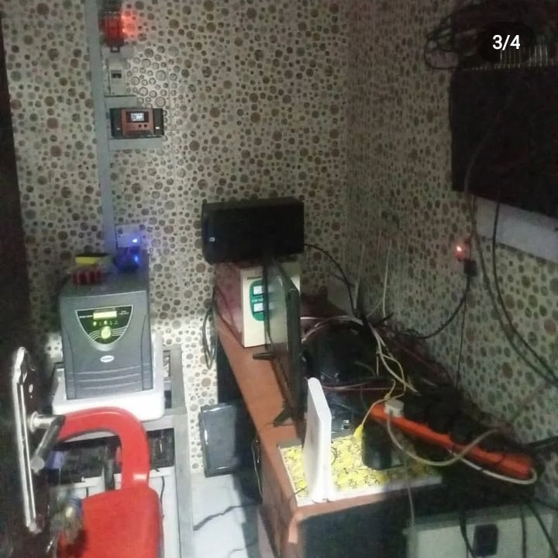

**E6 - notice of solar system not charging.**

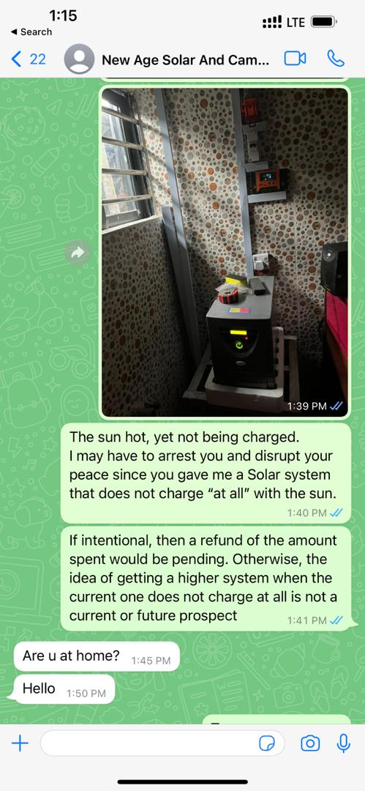**E7 - police visit, notice from police. (Event on April 19, 2022)**



**E8 - assassination attempt and property damage while in Police custody.**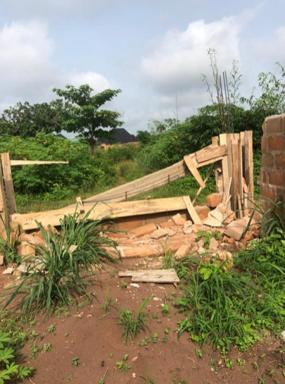

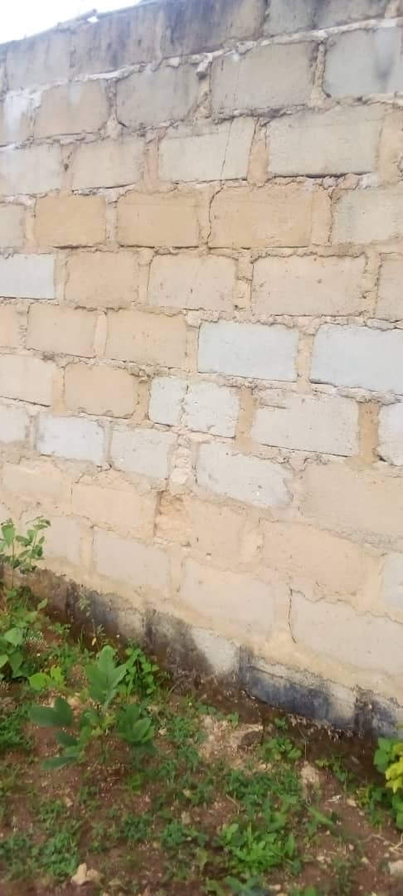

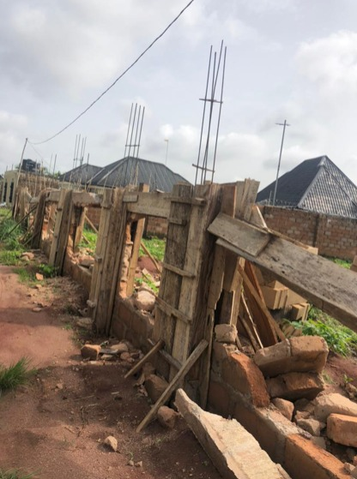**E9 - December 2021 - January 2022 blackouts on CCTV**

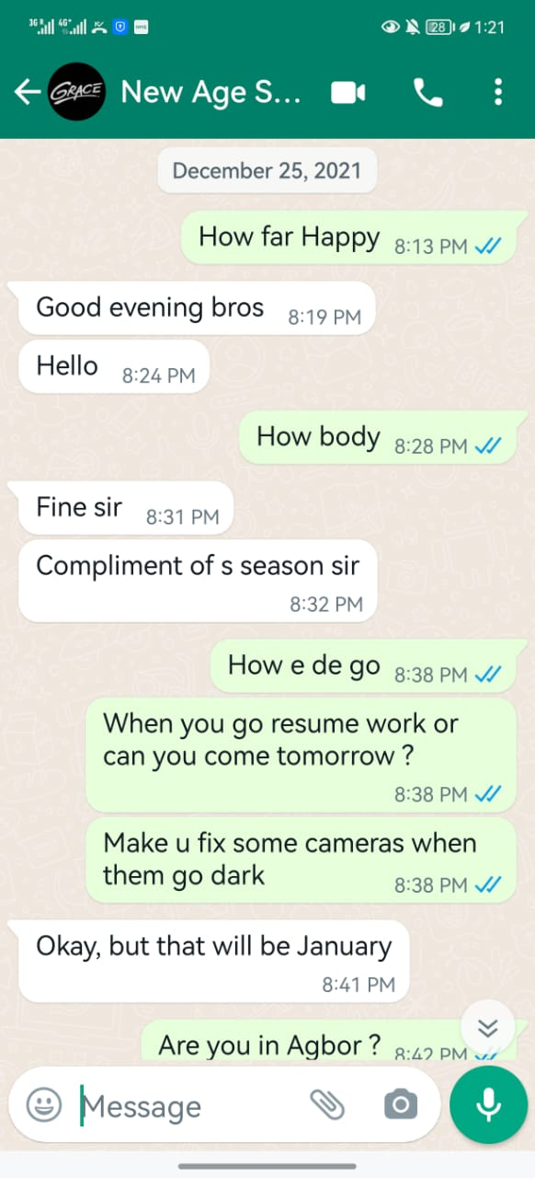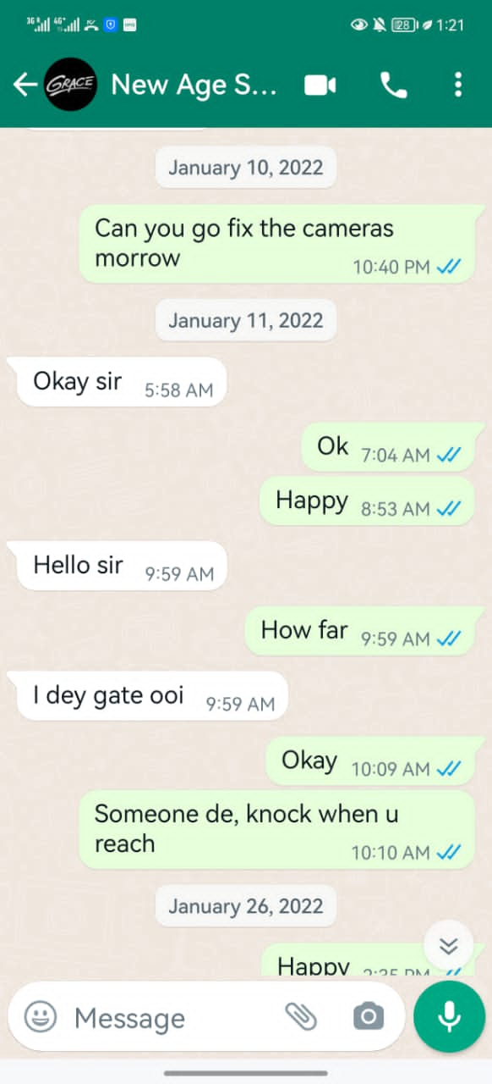

**E10 - methods of forced entry**

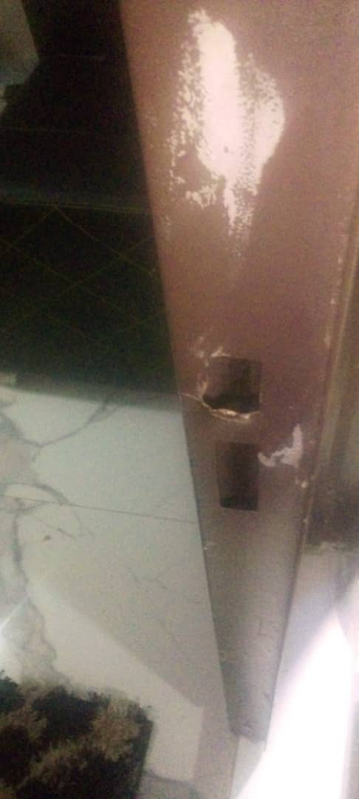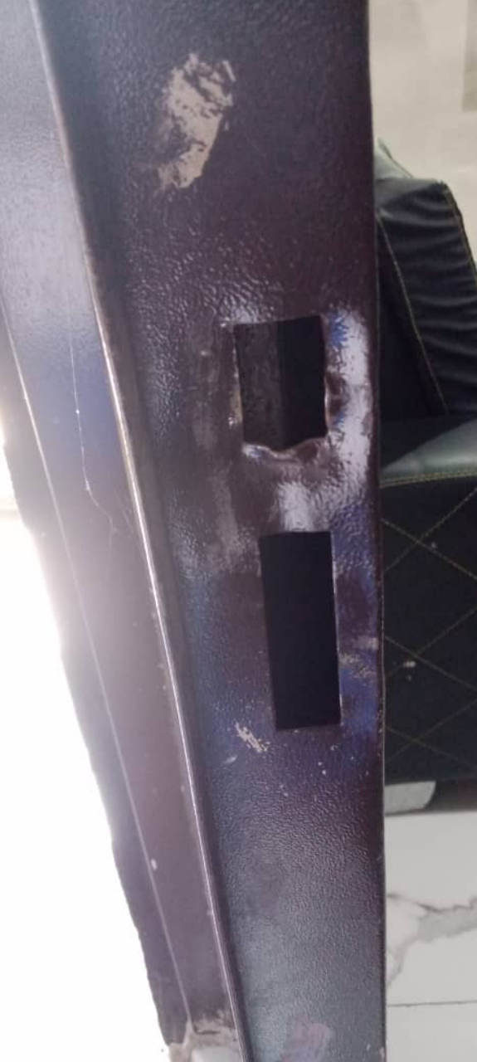

**E11 - Notice to solar company of office closing hours at 3pm. Notice to all**

**staff of closing hours at 3pm.**

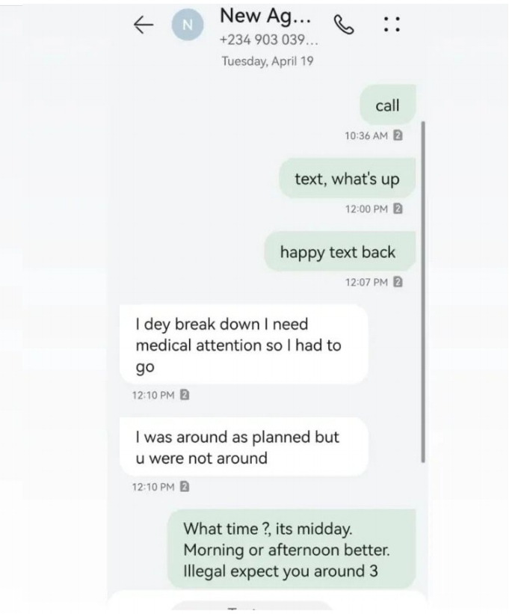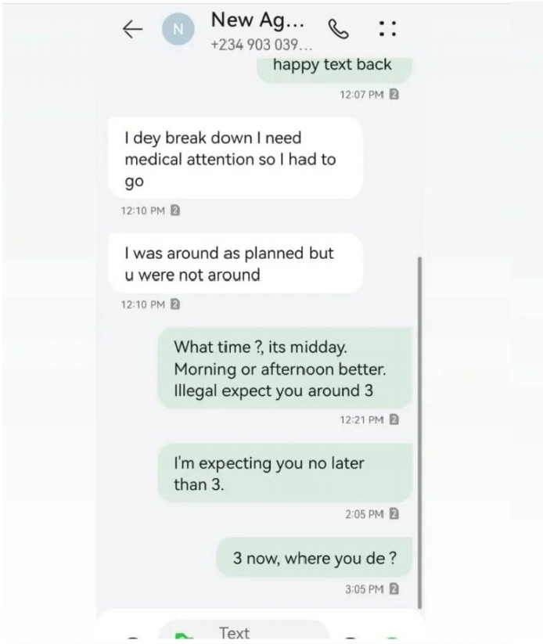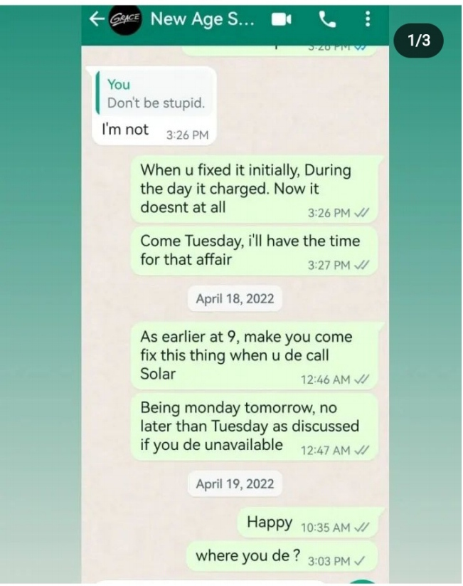

**Mouka W.E. Tega**

(Operations Manager, NNAI)